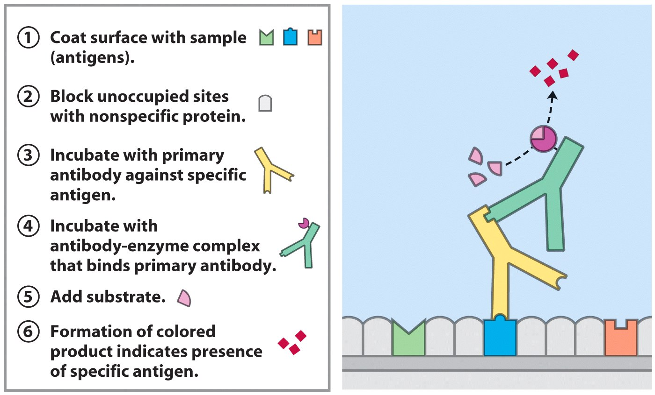

Immunology - Antigen/Antibody Reactions
ELISA Test
PA Standards:
PA S. T. & E.:
3.1.10.A7. Describe the relationship between the structure of organic
molecules and the function they serve in living organisms.

Introduction:
One of the body’s most important defense mechanisms against infection is the production of proteins called antibodies, or immunoglobulins. These proteins are produced by white blood cells and circulate in the bloodstream as part of the blood plasma. The production of antibodies is stimulated by the presence of foreign agents such as viruses and bacteria. White blood cells can identify molecules located on the foreign agents. These molecules are also proteins and are referred to as antigens. The antibodies produced in response to the antigens bind specifically to the antigens and render them harmless. Under normal circumstances, your body does this any time a foreign protein is identified in your body fluids and the response is the destruction of the foreign substance. It is important to remember that a specific antibody will bind only to the antigen that it was manufactured for. This phenomenon is the basis of the body’s defense against disease.
There are many laboratory procedures that utilize the antibody-antigen reaction. One such test is called ELISA (Enzyme Linked Immunosorbent Assay). This technique is used to detect and quantify specific antibodies found in blood serum. In ELISA, serum to be tested is allowed to react with specific antigens. Serum antibodies that combine with the antigens are detected by treating the test with a secondary antibody which has an enzyme attached to it. The secondary antibody is called a conjugate and it binds to the antibody-antigen complex and serves as a marker. Later in the test a substrate for the enzyme is added. The substrate will react with the enzyme and produce a color change If no serum antibodies were present to bind with the antigen and the conjugate, no enzyme-substrate complex will form and therefore no color change will be observed. This test is done in polyvinyl well plates under controlled conditions. A positive control that can be a recombinant or natural sample of the antigen that will be detectable is used. Also, a negative control that receives no treatment and should not show any change is part of the protocol.
The ELISA test can be used as preliminary screening for HIV, Lyme disease, pernicious anemia, Rocky Mountain spotted fever, rotavirus, syphilis, toxoplasmosis, varicella-zoster virus, which causes chickenpox and shingles, and Zika virus. ELISA is often used as a screening tool before more in-depth tests are ordered. A doctor may suggest this test if a person is having signs or symptoms of the conditions above, or if they want to rule out any of these conditions (Healthline 2020).
An article from the Mayo Clinic (Ledger, K. 3 April 2020) discussed ELISA as a widely used serologic test that detects specific proteins in samples and can detect SARS-CoV-2 antibodies. This can reveal whether a person might have developed immunity to COVID-19. Researchers haven't determined yet whether a person who has had and recovered from COVID-19 is protected from getting it again. But anecdotal evidence from China; preliminary studies in animal models; and experience from previous outbreaks, like severe acute respiratory syndrome and Middle East respiratory syndrome, suggest this might be the case.
Having a serologic test may provide the opportunity to tell, for example, whether health care workers have developed immunity. Although such health care workers would still be required to wear personal protective equipment, they would be at lower risk for getting re-infected, compared to health care workers who do not have this immunity. A serologic test also might be used to determine the levels of COVID-19-related antibodies in a person's blood ― information that may be useful in the experimental treatment known as convalescent plasma therapy. Plasma is the component of the blood with no blood cells. The idea behind this treatment, which involves giving patients an infusion of antibody-rich plasma from those who have recently recovered, is that COVID-19 antibodies might neutralize the virus or jump-start a patient's own immune response. Researchers studying COVID-19 in China have suggested in two small case studies of patients that donors need to have high levels of antibodies in their blood for the therapy to work.
While the blood test is not used for initial diagnosis, on a large scale, serology also can provide essential information in tracking where the disease has been and forecasting future hot spots. The virus may no longer be detectable in some people, but confirming whether a population has been exposed can reveal which geographic areas are vulnerable and which are not. What's clear is that serology will contribute to wide-ranging areas of COVID-19 diagnosis, treatment and research. Researchers will want to use serology to learn more about timing. For instance, how soon after infection do patients with COVID-19 develop antibodies? This information may help track the progress of the disease. How long do COVID-19 antibodies last in the body? The answer will be helpful in the development and scheduling of an eventual vaccine. Ultimately, serology will provide a crucial tool to track and address the pandemic. Mayo's test launched in early April, but it will not be widely available for some time due to limited availability of components (Ledger, 2020).
According to a NYT article (4/20/20) although 90 tests are now on the market, they are often inaccurate. Most tests now available mistakenly flag at least some people as having antibodies when they do not, which could foster a dangerously false belief that those people have immunity. The rapid test versions are especially not valuable for diagnosis. The most reliable ones involve a laboratory ELISA test that can indicate the number of antibodies a person may have. Just four have received F.D.A. approval: Cellex, Ortho Clinical Diagnostics, Chembio Diagnostic Systems and the Mount Sinai Laboratory. Even Cellex’s F.D.A.-authorized test has a false positive rate of about 5 percent. That is still a significant margin of error: “In a community where 5 percent of people have had the virus, Dr. Osterholm said, there would be as many false positives as true ones.” This shows the scope of the problem with obtaining enough reliable tests as this lab summary is written.
This lab uses a basic simulation of the ELISA test using inorganic chemicals to fit within the time frame of a secondary science lab period. A diagram of an actual possible test protocol from EDI, Epitope Diagnostics follows at the end of this lab.
Definitions:
Antibody: A protein produced by white blood cells (B-cells) in response to a foreign chemical or disease organism in the body. Antibodies bond to the foreign substance, aiding the body’s ability to recognize and remove the foreign material.
Antigen: A term for a foreign material in the body. Antigens could be carbohydrates, lipids, nucleic acids, proteins, dust, bacteria, viruses, etc. They stimulate an immune response in animals with an immune system.
ELISA: (Enzyme Linked Immunosorbent Assay). This technique is used to detect and quantify specific antibodies found in blood serum.
Serology: The scientific study or diagnostic examination of blood serum, especially with regard to the response of the immune system to pathogens or introduced substances.

Guiding Questions:

- Distinguish antigens from antibodies.
- Describe the antibody/antigen reaction.
- Describe the ELISA test.
- Why is this test important clinically?

Materials:
safety glasses HIV antigens
gloves positive control
paper towels negative control
test well plate donor 1 serum
stopwatch donor 2 serum
transfer pipettes secondary antibody
marking pen substrate

Safety Notes:

1. Although no human products are used, the chemicals you will be working with are irritants. Avoid eye/skin contact and do not ingest. Flush spills with water for 15 minutes. Notify your instructor.
2. Wear safety glasses and gloves at all times.
3. Wash your hands thoroughly for 20 seconds with soap at the end of each lab session.

Procedure:

- Place your initials on the test well plate and put it on a paper towel; label the first column wells vertically 1,2,3, & 4.

2. Using a transfer pipette, place one drop of HIV antigen in the center of each well on the well plate in the first column.

- Incubate at room temperature for 2 minutes.

- Using a new transfer pipette, place one drop of the negative control to the well; in row 1.

- Using a new transfer pipette, place one drop of the positive control to the well in row 2.

- Using a new transfer pipette, place one drop of donor 1 serum to the well in row 3.

- Using a new transfer pipette, place one drop of donor 2 serum to the well in row 4.

- Gently shake the well plate then incubate at room temperature for 2 minutes.

9. Using a new transfer pipette, place one drop of secondary antibody to all wells.

10. Gently shake the well plate then incubate at room temperature for 2 minutes.

11. Using a new transfer pipette place one drop of substrate to all wells.

12. A pink color change indicates a positive test result; if well remains clear is negative. Record the color changes on the data sheet.

Well Plate Diagram

Only one column will be used per lab group; Vertically label the wells 1, 2, 3, 4

DIAGRAM OF ELISA STEPS USING TRANSER PIPETTE

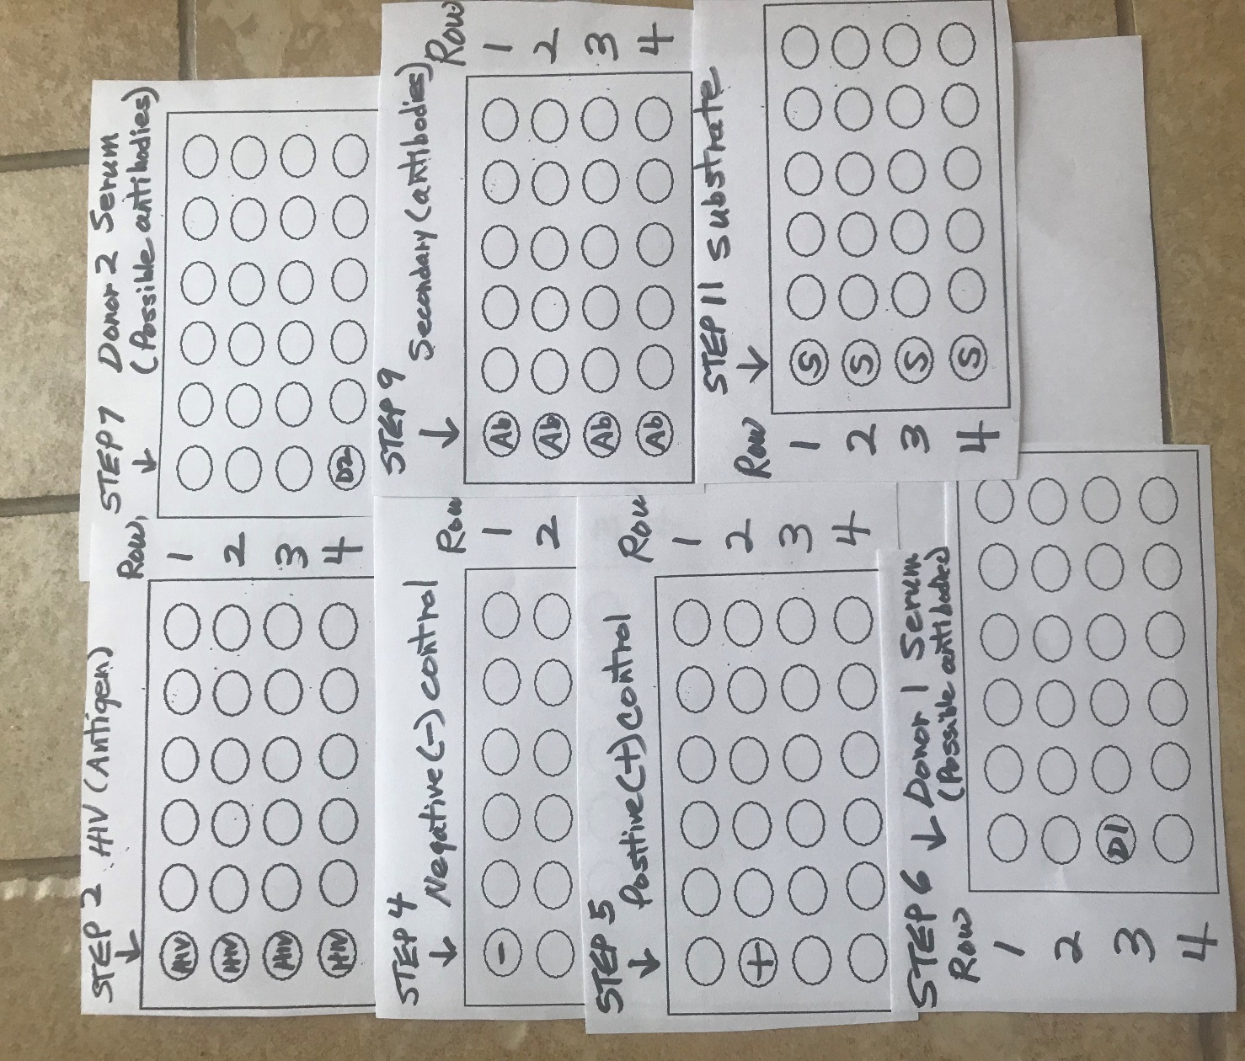

Diagram of ELISA protocol for Novel Coronavirus COVID-19

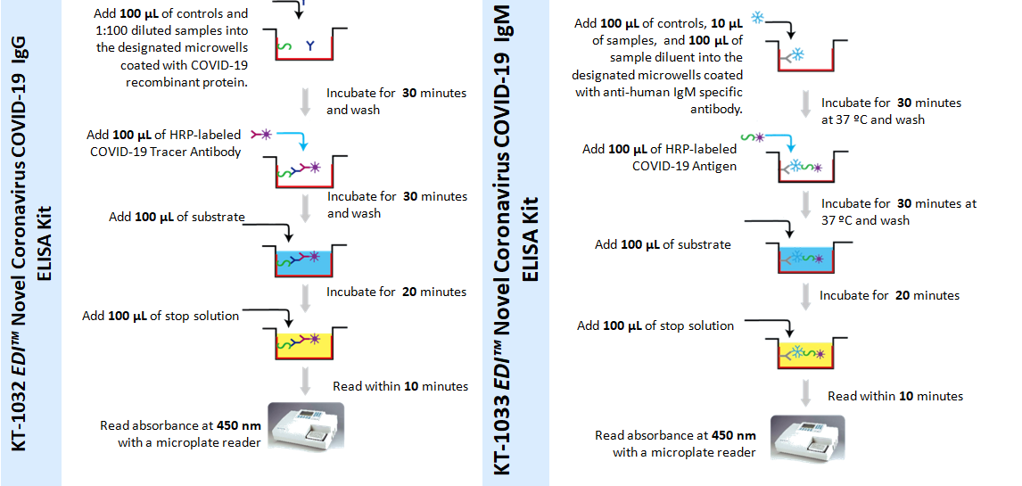

EDI Epitope Diagnostics [Internet 7 April 2020]. The Microplate reader is similar to a spectrophotometer; the absorbance of light is measured and helps determine quantity of the antibodies present: light in color less, deeper color more. Both sides show the same procedure for IgG and IgM antibodies. IgG is the most abundant antibody, is found in all fluids and protects against bacterial and viral infections. IgM, found mainly in blood and lymph fluid, is the first antibody made by the body to fight a new infection (kidshealth.org [Internet 7 April 2020].

References:

Baranoski, A. 19 April 2020. Interview ELISA, COVID-19, lab information, teacher notes. Drexel Medicine, Philadelphia PA.

Baranoski, K. 2020. Revisions to ELISA Lab information and teacher notes, diagrams, information on COVID-19. Wilkes University Science in Motion, Wilkes-Barre, PA.

Carnegie Mellon Website. [Internet 1 June 2011] @
www.andrew.cmu.edu/user/berget/Education/AIDS/html.AIDS_gifs/ELISA.gif } introductory diagram.

EDI Epitope Diagnostics, Inc. [Internet 7 April 2020] @ http://www.epitopediagnostics.com/covid-19-elisa

Hale, C. FDA officially authorizes its first serological antibody blood test for COVD-19. [Internet 3 April 2020]@ https;//www.fiercebiotech.com/medtech/fda-officially-authorizes-its-first-serological-antibody-blood-test-for-covid-19

Heathline. [Internet 7 April 2020] @ https://www.healthline.com/health/elisa

Ledger, K. Mayo Clinic. The importance of antibody testing in addressing COVD-19. [Internet 3 April 2020] @
https://discoverysedge.mayo.edu/2020/04/03/the-importance-of-antibody-testing-in-addressing-covid- 19/?_ga=2.124885578.1759388361.1586963587-219611372.1586809672

Mintz, J. Coronavirus COVID-19: Latest News and Information. [Internet 10 April 2020]@ https://www.medicinenet.com/script/main/art.asp?articlekey=229579 Mount Sinai Hospital mentioned in NYT as one of approved antibody tests; article not included in ELISA Teacher Notes.

Kid’s Health from Nemours. [Internet 7 April 2020] @
https://kidshealth.org/en/parents/test-immunoglobulins.html

NYT. 2020. Antibody test, seen as key to reopening country, does not yet deliver. [Internet 20 April 2020] @ https://www.nytimes.com/2020/04/19/us/coronavirus-antibody-tests.html . Brief summary in student lab; more detailed summary in ELISA Teacher Notes

Schultz, E. 19 April 2020. Citizen’s Voice. Put to the test; Arena readies for COVID-19 drive-thru testing set to begin on Monday.

Stull, R. 2011. Original lab design. Wilkes University, Wilkes-Barre, PA

Terry. M. FDA approves Rutger’s saliva test for COVID-19. [Internet 13 April 2020]@
https://www.biospace.com/article/rutgers-s-saliva-test-for-covid-19-approved-by-fda
Listed in ELISA Teacher Notes

Tiner, S. Mayo Clinic. The science behind the test for the COVID-19 virus. [Internet 28 March 2020] @ https://discoverysedge.mayo.edu/2020/03/27/the-science-behind-the-test-for-the-covid-19-virus/?_ga=2.179961700.1759388361.1586963587-219611372.1586809672 Information detailed in ELISA Teacher Notes.

Wignot, T. 2011. Previewed, updated original lab procedure, obtained diagram on page 1. Wilkes University, Wilkes-Barre, PA

Student Data Sheet

Name_____________________________ Date ________________

Observations:

Record the color changes observed in the wells.

Row 1_________________________

Row 2_________________________

Row 3_________________________

Row 4_________________________

Analysis/Conclusions:

- Which donor/donors has been exposed to the HIV virus? How do you know?

- Which what is the purpose of the positive and negative controls?

- What is the purpose of the secondary antibody?

- Why is a substrate needed for the results to be determined?

- Summarize the reactions occurring during the ELISA test.

- After a pandemic like the novel coronavirus, why are antibody tests like ELISA important?

