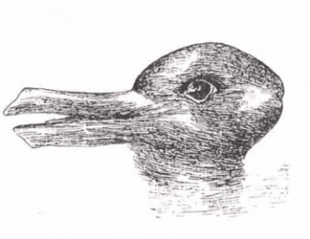
Observation Lab- Optical Illusions
Figure 1: What animal(s) do you see? Pick one that is more likely and defend your choice.
Figure 2: What do you see where
the white bars meet?

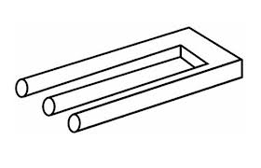
Figure 3: What is wrong with this figure?

Figure 4: Who is taller? Use your ruler (in cm) to measure each person.

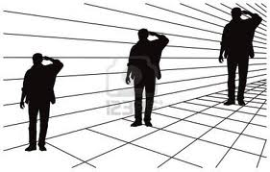

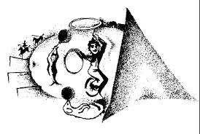
Figure 5: Rotate clown to the right 90 degrees. What happens?
Figure 6: Rotate this face 180 degrees (up-side-down). What happens?
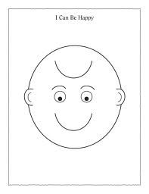
Figure 7: What do you see first? Look again- what else is there?

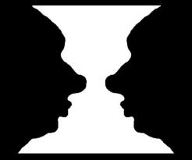
Figure 8: What do you see first? Look again- what do you see now?

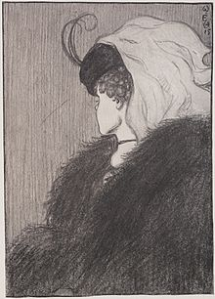

Figure 9: What President do you see? Look more closely at several other living things;
name as many as you can find.

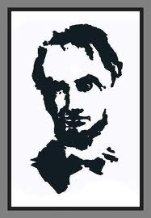

Figure 10: Stare at the space between the bull’s eye and arrow. What happens?
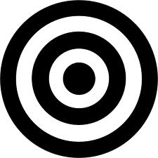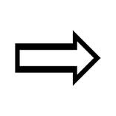

Student Data Sheet- Optical Illusions

Name ______________________________ Date _________________

Figure 1:

Figure 1. What animals do you see? ______________ _________________

Pick one that is more likely: _______________ Defend your choice ___________________

__________________________________________________________________________

__________________________________________________________________________

Figure 2. What do you see where each white meets the next one? _______________________

____________________________________________________________________________

Figure 3. What is wrong with this figure? ___________________________________________

___________________________________________________________________________

Figure 4. Who is taller? (Answer after measuring each person) __________________________

Person on left = _____ cm. Person in middle = _____ cm. Person on right = _____ cm.

Figure 5. What happens when you rotate the clown 90 degrees? ______________________

____________________________________________________________________________

Figure 6. What happens when you rotate the face 180 degrees? ________________________

_____________________________________________________________________________

Figure 7. What do you see first? ________________________ Look again- what else is there?

_________________________________

Figure 8. What do you see first? _________________________ Look again- what do you see?

__________________________________

Figure 10. What happens when you stare at the space between the bull’s eye and the arrow?

____________________________________________________________________________

Analysis: Write a paragraph discussing what each of these Figures have in common and what you have learned from this activity. Also include information on which illusions were more difficult or easier to observe. Finally, if you have observed other optical illusions before briefly mention these.

Extra credit (+ 3 points): A phenomenon called the Purkinje shift is related to the way our eyes function as they slowly adjust from color vision that operates in bright light to night vision that operates in dim light. Reds and yellow seem brighter to you in daylight and seem less bright than greens and blues at dusk. For this reason greens seem unnaturally bright as the light fades. You may also notice this shift when you look outside during a summer shower. Tonight or the next sunny day at dusk observe this event and write a paragraph describing what outside objects or living things you observed.

Extra credit (+ 3 points): Draw an optical illusion of your own.

Extra credit (+ 3 points): Research (in a book or from the web) two new optical illusions not shown in this activity. Learn the theory behind how they work and bring to share with classmates.

Teacher Notes

Explanations for illusions: (Many are for your information rather than for the children - depending on grade level). Every detail does not have to be explained, these can just be enjoyed as an observation activity.

Figure 1: A duck and rabbit can be seen. This is a famous example of gestalt psychology- basically the whole is greater than the sum of its parts. The principle maintains that the human eye sees objects in their entirety before perceiving their individual parts. Gestalt psychologists stipulate that perception is the product of complex interactions among various stimuli.

Figure 2: This is called the Hermann Grid. Gray spots are seen at the intersections. One reason is that the white appears to be whiter when it is next to black. The white bars between the black squares appear whiter than at the intersections. An intersection is seen as white meeting white and less than white than next to black. Darker areas are the result. It also has to do with the rods in the retina that are firing inhibiting neighboring receptors from firing, thus producing areas of darkness.

Figure 3: It is not attached anywhere, which is called a blivit, or an “impossible” picture that is the result of two sets of information from the same source that cannot exist together. When you look at the separate parts, they appear possible, but when our brain tries to figure out how the whole picture is pout together, we run into trouble.

Figure 4: The three persons are actually the same height (2.7 cm). This illusion is caused by the narrowing of the lines and squares towards the back of the figure; the narrower lines make the last person appear to be taller. The first person has wider lines behind the image making him/her appear shorter.

Figure 5: The viewer will see a circus ring with jugglers and animal acts. During the early part of the 20th century some painters became “surrealists” because their paintings passed beyond the appearance of ordinary reality. One technique was double painting; the clown is an example of this type of art.

Figure 6: This drawing is called a “smily/frowny face”. When the paper is rotated 180 degrees and face is up-side –down the figure is frowning.

Figure 7: One observation of the drawing (white center) produces a curvy vase, the black background shows two side profiles facing each other.

Figure 8: A person viewing this drawing might see a young or older lady. Hint: The young lady’s chin and ear become the older lady’s nose and eye. This is called a transformation and is an illusion consisting of two very different drawings. This transformation is often studied by psychologists.

Figure 9: Black and white shapes of other living things include a mouse, camel, snail, clown, goose, profile face, and a dog’s head.

Figure 10: It appears as though the arrow “shoots” right at the target bull’s eye. This works because when the page is close to your face, one eye sees only the arrow while the other eye sees only the bull’s eye. Your brain must put the two pictures together.

More on the Purkinje effect: The retina at the back of the eye has cones to perceive color which are more active in brighter illumination, and rods for black and white and darker illumination or night vision. At dusk the cones are switching over to rods as it gets darker. This is why greens appear brighter than reds or yellows at this time.

