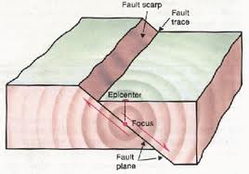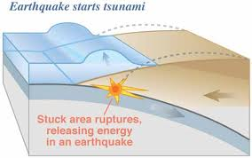
Earthquakes
Directions: Carefully review the table and answer the following questions. Worldwide Earthquakes, 1990-1994
Magnitude | 1990 | 1991 | 1992 | 1993 | 1994
8.0-9.9 | 0 | 0 | 0 | 1 | 2
7.0-7.9 | 12 | 11 | 23 | 15 | 13
6.0-6.9 | 115 | 105 | 104 | 141 | 161
5.0-5.9 | 1,635 | 1,469 | 1,541 | 1,449 | 1,542
4.0-4.9 | 4,493 | 4,372 | 5,196 | 5,034 | 4,544
3.0-3.9 | 3,457 | 2,952 | 4,643 | 4,263 | 5,000
2.0-2.9 | 2,364 | 2,927 | 3,068 | 5,390 | 5,369
1.0-1.0 | 474 | 801 | 887 | 1,177 | 779
0.1-0.9 | 0 | 1 | 2 | 9 | 17
No Magnitude | 5,062 | 3,878 | 4,084 | 3,997 | 1,944
Total | 16,612 | 16,516 | 19,548 | 21,476 | 19,371
Estimated Deaths | 51,916 | 2,326 | 3,814 | 10,036 | 1,038
1. According to this information, which magnitude earthquakes were the most common
between 1990 and 1994?
A No magnitude C 4.0-4.9
B 3.0-3.9 D 5.0-5.9
2. According to the information in the table, the year that experienced the most deadly
earthquake activity was ________.
A 1992 C 1993
B 1994 D 1990
3. According to the table, the year that had the greatest number of earthquakes was _____.
A 1992 C 1993
B 1991 D 1990

