**More Cognitive Organizers**

**YOUR TICKET OUT**

Take a few minutes and reflect upon what you’ve learned today.

Today we learned (think of at least three things):

1.

2.

3.

We have these questions &/or concerns

______________________________________________________________________________

**MRS. POTTER’S QUESTIONS**

1. What were you supposed to do?
2. What did you do well?
3. What would you do differently next time?
4. Did you need any help or have any questions?

**Fish Bone:** 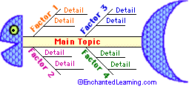

**A fishbone map** (sometimes called a herringbone map) is a type of [graphic organizer](http://www.enchantedlearning.com/graphicorganizers/) that is used to explore the many aspects or effects of a complex topic, helping the student to organize their thoughts in a simple, visual way. The use of color helps make a fishbone map clearer and easier to interpret.

If the topic at hand involves investigating attributes associated with a single, complex topic, and then obtaining more details on each of these ideas, use a fishbone diagram as your graphic organizer.

**Examples of Fishbones:** For example, a fishbone diagram can be used to prepare for a writing assignment; the student must concentrate on the main topic, list the big ideas concerning the topic, and think of the attributes/qualities/functions/effects associated with each of these ideas.

[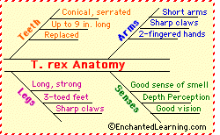](http://www.enchantedlearning.com/subjects/dinosaurs/dinos/trex/)

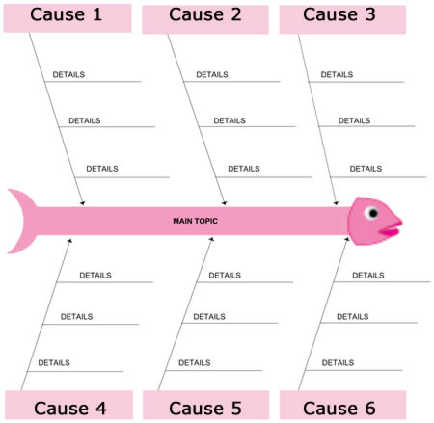* Another Fishbone Example

**Matrix:**

The graphic organizer able to demonstrate perhaps the widest range of complexity is the matrix. Matrices are constructs of rows and columns. They can span a range from simple, one column matrices to unlimited matrices. They can be used to compare and contrast two items, or they can be used to list objects cross-referenced with the attributes of each object.

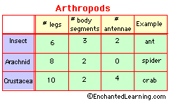

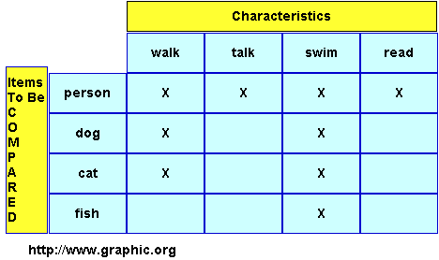

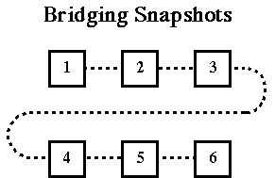**bridging snapshots picture**

The connected boxes of a **Sequence Chart** show a progression (changes over time), series of steps, cause and effect, or succession of information. It does not focus on the priority or importance of information; rather itshows connections in the form of a timetable, cycle, or chain of events. For example, youcould identify the activities necessary to complete a project.

**Right Angle Chart:**

*Right Angle Diagram (Reflection)* – This organizer is a reflective tool which has the two lines of a right angle. It is a useful tool which allows students to break any mind sets they bring to a problem. The items on the horizontal bar are the facts related to the problem or issue. The items on the vertical bar represent the students' thoughts and feeling about the problem or issue. The organizer allows students to shift their perspective away from the facts to their feelings and vice versa. This is an excellent tool for examining literature, art, major events and issues.

Students complete the diagram by listing facts about the topic on the right and feelings and associations on the left.  
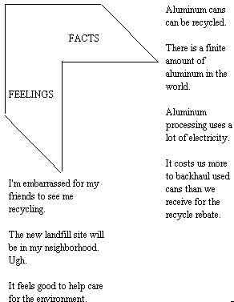

**References:**

Bellanca, J. & Fogarty, R. 1991. Blueprints for thinking in the cooperative classroom. Palatine: Illinois: IRI/Skylight Publishing, Inc.

Bridging snapshots. {Internet} Retrieved 7 March 2012. Available at:

<http://www.africangreyparrott.com/graphicorganizers.pdf>

Burke, K. 1993. *The Mindful School: How to Assess Thoughtful Outcomes.* Palatine, Illinois: IRI/Skylight Publishing, Inc. *Pgs. 117-126.*

Chart example. {Internet} Retrieved 7 March 2012.

Available at: <http://www.enchantedlearning.com/graphicorganizers/chart/>

Enchanted Learning. {Internet} Retrieved 7 March 2012. Available at <http://www.enchantedlearning.com/graphicorganizers/fishbone/>

Graphic.Org. {Internet} Retrieved 7 March 2012.

Available at: http://www.graphic.org/goindex.html/

Matrix explained. {Internet} Retrieved 7 March 2012. Available at: [http://www.cod.edu/people/faculty/drafke/graphic%20organizers.htm#](http://www.cod.edu/people/faculty/drafke/graphic%20organizers.htm) A Matrix

Read more at Suite101: [Graphic Organizers - Thinking Strategies for Classroom Use | Suite101.com](http://juliedawnwee.suite101.com/graphic-organisers---thinking-strategies-for--classroom-use-a304060#ixzz1oPO31xfp) <http://juliedawnwee.suite101.com/graphic-organisers---thinking-strategies-for--classroom-use-a304060#ixzz1oPO31xfp>