NAME ________________________________________________________DATE_______________
ACTIVITY: How Can Learning Be Measured?
Objectives: Determine how repetition affects learning.
Construct a graph to show how repetition affects learning.
Materials:
- 15 – 3” x 5” index cards for each group
- black or colored markers
- stopwatch or clock with a second hand for each group
Procedure:
A. Using the index cards and the same color marker for all letters, write the first 15 letters of
the alphabet, one letter on each card. Try to make letters large and all similar in size.
B. Scramble the lettered index cards and lay them on your desk in a 5 by 3 card array, letter side up.
C. Have a classmate keep time with the stopwatch or clock. When your classmate says “go,” use
your index finger to touch each of the squares in alphabetical order. You may name the letters as
you do this. Record the number of seconds it took to touch all the letters in order under Time in
the table below for Trial 1.
Trial | Time (sec.)
1
2
3
4
5

D. Repeat step C four more times as Trials 2 – 5. DO NOT MIX THE CARDS BETWEEN TRIALS.
E. Graph your results on the next page.

Graph of Time vs. Trial #

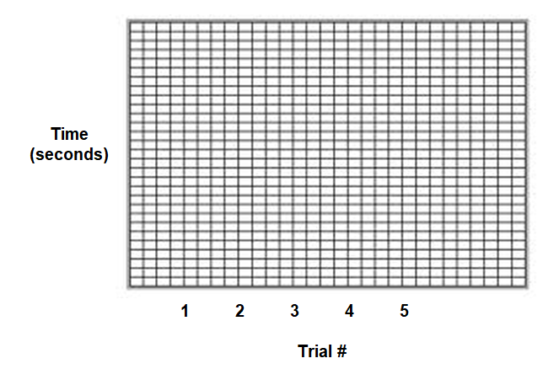
Results and Conclusions:
1. How long did it take to touch the letters the first time? ____________ Did the amount of time

increase or decrease with each trial? _________________ Explain why this change occurred.
______________________________________________________________________________
______________________________________________________________________________
______________________________________________________________________________
2. Explain why you were not supposed to mix the cards for each trial.
__________________________________________________________________________
__________________________________________________________________________
3. Predict what the graph would look like if you repeated the task ten more times.
____________________________________________________________________________
____________________________________________________________________________
(Silver, Burdett, & Ginn, 1988)

