Oreo Cookie Moon Phases
Posted by ScienceBob on Tuesday, April 12, 2011 · 7 Comments

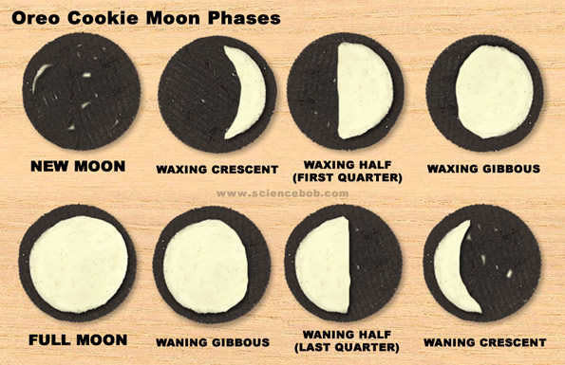
I’ve always been a fan of science activities that you can eat. One of my favorites that I have been using for years is the Oreo Cookie Moon Phases activity. It’s almost as if Oreo cookies were made for this lesson, and it’s a great way to see how well students can match a moon phase name with a moon phase appearance.
You will need:
- An Oreo cookie for each student
- A piece of paper with a moon phase written on it for each student (I omit “Full moon” – that’s just too easy)
- A popsicle stick or other tool for scraping the frosting
What to do:
- Fold up each piece of paper with the moon phases written on it and hand one to each student as they enter the room – tell them not to open it yet. I will often have them store it in their shoe. They think that’s funny, and they won’t lose it.
- Demonstrate the proper way to slowly twist an Oreo to maximize the amount of frosting on one side when you separate the halves. (practice yourself, it can be tricky)
- Give each student a cookie and have them twist the halves open. Hopefully most will the frosting will be on one side or the other. They can always transfer frosting if needed.
- Have the student retrieve their moon phases while you hand out the craft sticks.
- Recreate the given phase in frosting!
I will usually tour the room and once they show me that they’ve got the phase right, they can eat the moon! Of course be aware of food allergies and such. If you try this out, let me know how it goes!

