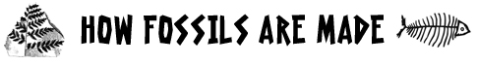

How Fossils Are Made

The Kinds of Fossils

Paleontologists are people who study ancient life. Because they study life forms that are now extinct, they rely on fossils to learn about life in the past. Fossils are the remains of living things that have transformed into stone over millions of years.

Most fossils are found in sedimentary rock. The fossils are made when living things die and get buried by sediments quickly before the hardest parts of the animal have a chance to decay. As sediments accumulate, pressure causes the sediments to harden into rock: Sand sediments become sandstone, clay sediments become shale, and shell sediments become limestone.

Groundwater carrying minerals seeps into the sedimentary rock and helps the fossils form in one of two ways. Sometimes the minerals fill in all of the empty places of the once living thing and form crystals. These crystals cause the remains of the living thing to harden along with the sedimentary rock that it is encased in. Petrified wood is an example of this process, which is called permineralization.

At other times, the minerals in the groundwater actually replace the minerals that make up the remains. So over time the hard parts are completely replaced by other minerals. This process is called replacement.

Other important fossils are impressions and molds. These are made when a hard part such as a shell, fills up with sediments that harden, and then the actual shell dissolves leaving nothing but the sediment mold. These molds can tell us much about the body structures of animals and plants.

As well, insects also get trapped in amber, which is fossilized tree sap. In the movie Jurassic Park, scientists used dinosaur DNA from the stomachs of mosquitoes trapped in amber to genetically engineer dinosaurs.

Some animals have even been trapped in ice, too, preserving them extremely well. Woolly mammoths and mastodons have been found with hair intact and bones in good condition. Likewise, some animals and plants have been mummified in hot arid conditions like those found in deserts.

Finally, paleontologists can learn about ancient life from trace fossils. Trace fossils are things like footprints or animal droppings, which can tell us about the animal’s behaviour.
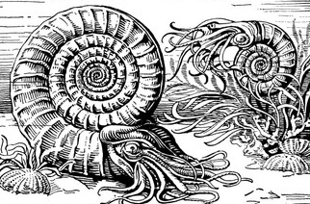

Living things (usually aquatic) die and then get buried quickly under sand, dirt, clay, or ash sediments. Usually, the soft parts decay, or rot away, leaving the hard parts behind. These are ammonites, one of the most common fossils that are found.

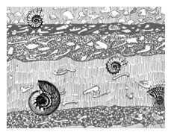

As time goes on more and more sediment accumulates. Pressure, heat, and chemical reaction cause the sediments to harden into rock called sedimentary rock.

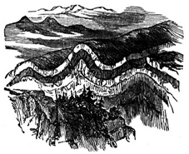

Movements in the earth’s crust, pushes the layers of sedimentary rock back up to higher ground.

Finally, through erosion caused by weather, wind, and water, the fossils become exposed at the surface again.
